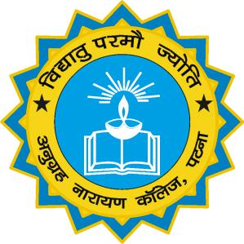

(A CONSTITUENT UNIT OF PATLIPUTRA UNIVERSITY, PATNA) (NAAC REACCREDIATED GRADE – ‘A’ & CPE STATUS BY UGC)

A PROJECT REPORT ON

E-Transaction Interface on Multiple Banking System

Submitted in partial fulfilment of the requirements for the award of the degree of Master of Computer Applications (MCA)

Department of Computer Applications (MCA),
(Approved By AICTE, New Delhi)
Anugrah Narayan College, Patna – 13

Guide: Submitted By:
Er. Anil Kumar Singh MANJEET KUMAR
College Roll No.: 53
Session: 2018-2021
Univ. Roll. No.: 1940172012297

SUBMITTED TO



Patliputra University, Patna

